Login / Registration Page

Definition
# Source: AI Source: Provided by: [Data Path: Persons Table -> ID Column: 1, Name_En Column: Motasem Essam] -> From: [Chatgpt (GPT‑5 Mini)] on [2/12/2026]
A Login / Registration Page is a web page where users can create an account (register) or sign in (log in) to access a website or application.

Simple Definition
# Source: AI Source: Provided by: [Data Path: Persons Table -> ID Column: 1, Name_En Column: Motasem Essam] -> From: [Chatgpt (GPT‑5 Mini)] on [2/12/2026]
Login / Registration Page = a page that lets users sign up or sign in to their account.

Main Parts of a Login Page
# Source: AI Source: Provided by: [Data Path: Persons Table -> ID Column: 1, Name_En Column: Motasem Essam] -> From: [Chatgpt (GPT‑5 Mini)] on [2/12/2026]
- Username / Email field
- Password field
- Login button
- Forgot Password link (optional)
- Remember Me option (optional)

Main Parts of a Registration Page
# Source: AI Source: Provided by: [Data Path: Persons Table -> ID Column: 1, Name_En Column: Motasem Essam] -> From: [Chatgpt (GPT‑5 Mini)] on [2/12/2026]
- Name field
- Email field
- Password + Confirm Password
- Sign Up / Register button
- Terms & Conditions checkbox (optional)

Purpose of Login / Registration Page
# Source: AI Source: Provided by: [Data Path: Persons Table -> ID Column: 1, Name_En Column: Motasem Essam] -> From: [Chatgpt (GPT‑5 Mini)] on [2/12/2026]
- Allow users to create personal accounts
- Give access to private features (profile, orders, dashboard, etc.)
- Keep user data secure
- Personalize user experience

Example Uses
# Source: AI Source: Provided by: [Data Path: Persons Table -> ID Column: 1, Name_En Column: Motasem Essam] -> From: [Chatgpt (GPT‑5 Mini)] on [2/12/2026]
- Social media (Facebook, Instagram, Twitter)
- Online stores (Amazon, e-commerce sites)
- Banking apps
- Learning platforms

Login vs Registration
# Source: AI Source: Provided by: [Data Path: Persons Table -> ID Column: 1, Name_En Column: Motasem Essam] -> From: [Chatgpt (GPT‑5 Mini)] on [2/12/2026]
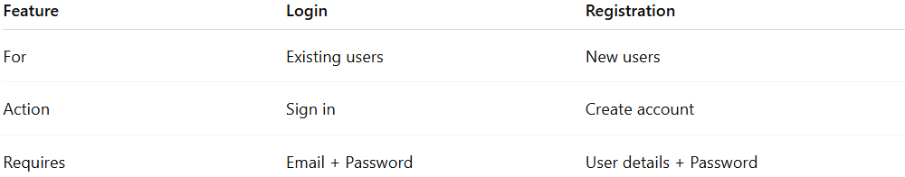
Feature | Login | Registration
For | Existing users | New users
Action | Sign in | Create account
Requires | Email + Password | User details + Password

